Biology Test Number 2

Year 10

Name _________________________________ mark=______/35

Section A

1. Connect the correct word to the correct meaning.

|  |  |  |
| --- | --- | --- |
| Word |  | Meaning |
| Evolution |  | One type of living thing with shared characteristics. Members of this group are able to mate with other members of this group and produce fertile offspring. |
| Species |  | The change in a species over many generations resulting in new species being made. |
| Generation |  | A living thing |
| Adaptation |  | The remains (or an impression) of a plant or animal that existed in a past and that has been dug up from the ground. |
| Fertile |  | The time between the birth of one animal and the time when that animal produces its own offspring |
| Fossil |  | Something that helps an organism survive in its environment |
| Organism |  | Able to reproduce and produce young. |

(7 marks)

Section B

Answer the next questions by placing an X on the answer you think is the most correct.

1. The selective breeding of dogs, to get dogs with characteristics that are useful for humans, is an example of:
2. Natural Selection.
3. Artificial Selection.
4. Speciation.
5. Evolution.
6. A horse and a donkey can mate to give an offspring called a Mule. Mules are not fertile. Mules cannot have baby mules. This tells us that:
7. Horses and donkeys are in the same species.
8. Horses and donkeys are in different species.
9. Horses and mules are in the same species.
10. Donkeys and Mules are in the same species.

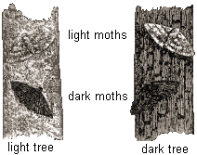Peppered moths live on the trunks of trees in England. The moths are eaten by birds. Some moths are light coloured and some are dark coloured. Long ago light coloured moths were more common.

When lots of factories were built in the 1800’s pollution made the surface of the trees near the factories dark.

By 1895 around 98% of moths living near cities with factories were dark.

This is an example of:

1. Natural Selection.
2. Artificial Selection.
3. Extinction.
4. Fossilisation.
5. The fossil history of horses is very good. Below are some pictures of the change in horses over time.

[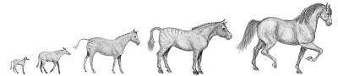](http://www.google.com.au/url?sa=i&rct=j&q=horse%20evolution&source=images&cd=&cad=rja&docid=MuwXfOPuozpkRM&tbnid=pDMxhT7QlzY9UM:&ved=0CAUQjRw&url=http://evolutionconspiracy.wordpress.com/about-the-book/&ei=xIVPUaC5PM6nkQWhuoCoAQ&psig=AFQjCNFr5h50rkGoIjoBMfAf1lPcVGWoQw&ust=1364252240225730)

This has been used as evidence for:

1. Artificial selection.
2. Evolution.
3. Fertility.
4. Extinction.
5. Speciation is:
6. The process where new species are made
7. The process where fossils are made.
8. The process where organisms with favourable characteristics become less common.
9. The process where humans breed animals with characteristics useful to humans.

(5 marks)

Section C

1. Into the box below draw a classification key for the following 4 things. A motor car, a horse, a motor boat and a snake.

|  |
| --- |
|  |

(4 marks)

1. Use the words in the list that follows to fill in spaces of sentences that follow the list.

Word list= evidence, comparative, ancestor, Darwin and DNA.

Sentences=

The picture below shows the front limbs of 4 different animals. This is an example of _______________ anatomy. It suggests that the 4 different animals may have a common _______________. This was used by scientists as _____________________ evolution. The Scientist who is famous for the theory of evolution is Charles _____________. One type of evidence for evolution that was not available to the famous scientist is ________ evidence.

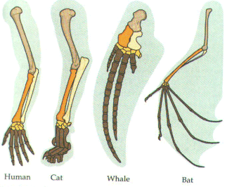

(5 marks)

1. Here is a picture of an elephant.[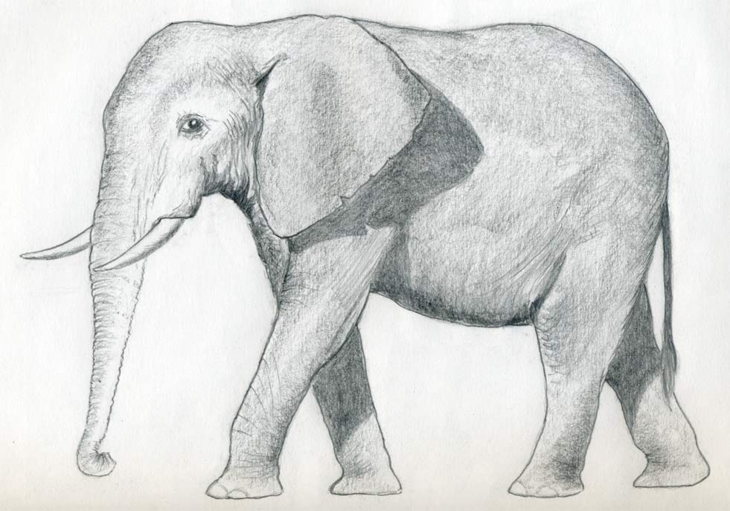](http://www.google.com.au/url?sa=i&rct=j&q=animal+drawing&source=images&cd=&cad=rja&docid=S-WagjBUjUxtfM&tbnid=yWDDhvt5_1EPzM:&ved=0CAUQjRw&url=http%3A%2F%2Fwww.easy-drawings-and-sketches.com%2Fdraw-an-elephant.html&ei=u_RsUZCRBcfwiAf1ooDwAw&psig=AFQjCNGPva--mnuLoLTv-B-X65UOdfnZ6w&ust=1366181414004127)
2. List as many characteristics as you can for this animal. You will get one mark for every three characteristics.

(3 marks)

1. Look at the picture below. Use it to draw a classification key for the animals shown.

[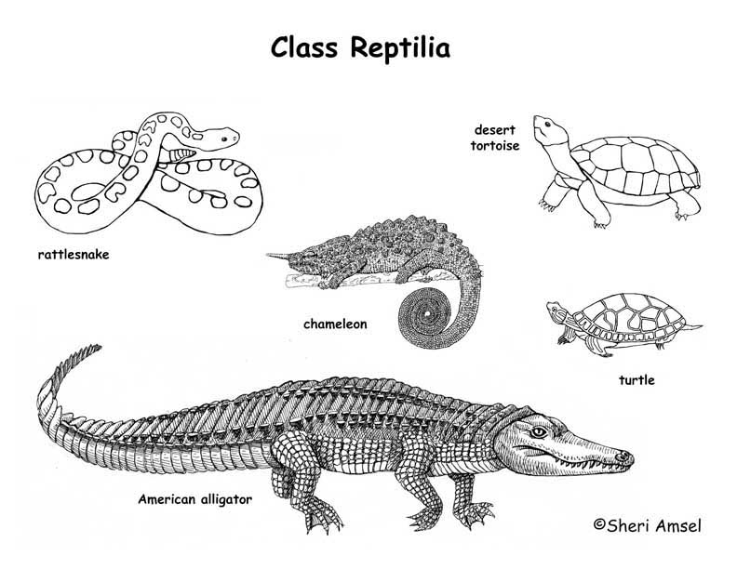](http://www.google.com.au/url?sa=i&rct=j&q=classification+chart&source=images&cd=&cad=rja&docid=H6AodNOZuHZdOM&tbnid=xAWBHZbc8IsiTM:&ved=0CAUQjRw&url=http%3A%2F%2Fwww.exploringnature.org%2Fdb%2Fdetail.php%3FdbID%3D87%26detID%3D1194&ei=l_JsUcLEMMewiQfvkoDwBg&psig=AFQjCNFuyTvFiSCeVz3jrUmR5MITe81q-Q&ust=1366180869137293)

(5 marks)

1. Speciation occurs in a number of stages. Variation, isolation and selection. For each one of these stages state what occurs.

|  |  |
| --- | --- |
| Stage | Description |
| Variation |  |
| Isolation |  |
| Selection |  |
| New species formed | New group is so genetically different from the original group that they can no longer reproduce together to give fertile offspring. |

(6 marks)